Plotting Polygons 6G3 Lesson 3: Classwork

Instructions: Work on the following problems with a partner.

1. For each of the following polygons, calculate the length of each side using Method #2: Calculating Using Coordinates. Make sure to show the calculation you used to find the length next to each side. At the end, check by using Method #1: Counting on the Coordinate Plane.

Polygon A  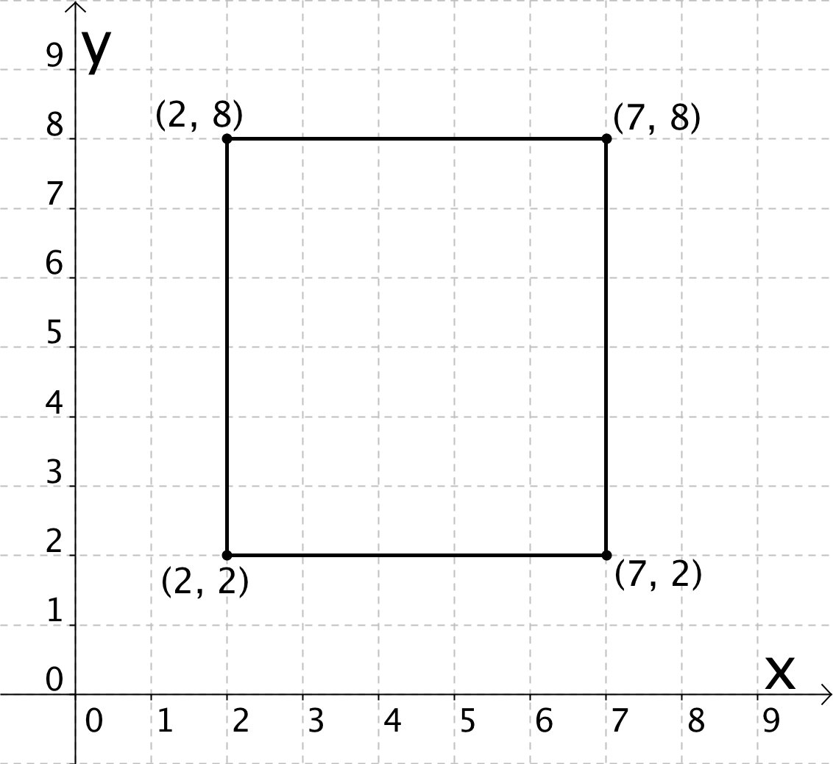 | Polygon B  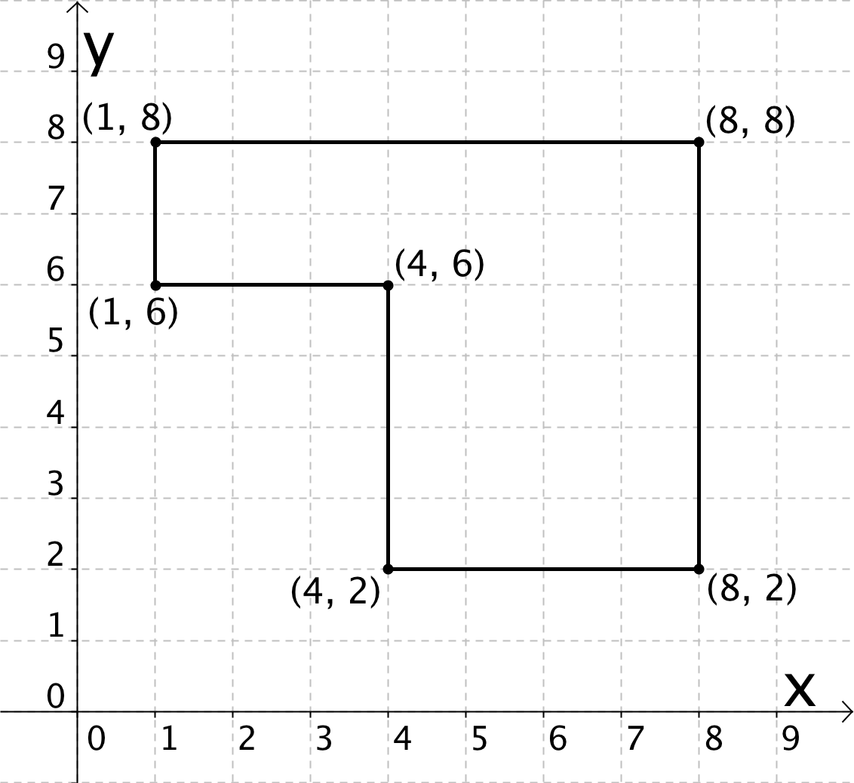
Polygon C  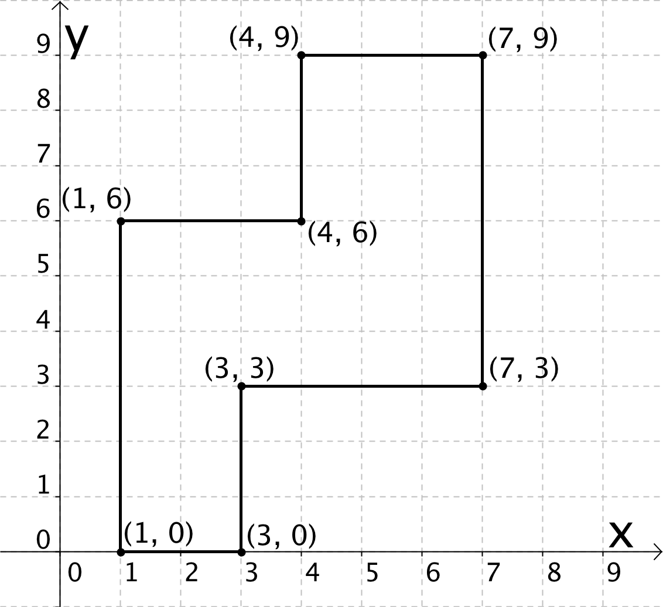 | Polygon D  