Histograms Notes

A ***histogram*** is a graph that displays data. Like a bar graph, a histogram uses bars to represent data. The bars

in a histogram do not have any spaces between them. In order to construct a histogram, you must divide the

data into intervals. The number of data points that fall into an interval is the frequency. This tells you

the height of each bar on a histogram.

Checklist for Histograms:

☐ Title

☐ Label on the x-axis (horizontal – left to right)

☐ Label on the y-axis (vertical – up and down)

☐ Equal spaces on the x-axis

☐ Equal spaces on the y-axis

☐ Intervals on the x-axis

Example: 1 – 5

6 – 10

11 – 15

16 – 20

☐ Scale on the y-axis

Examples: 0, 1, 2, 3, 4, 5

0, 2, 4, 6, 8, 10

0, 5, 10, 15, 20

☐ No spaces between bars



Science Test Scores

Scores

Frequency

No Spaces

Between Bars

Title

Label on Y-Axis

Scale:

Counting

by 10’s

Intervals: Each interval starts

where the previous one left off

Label on X-Axis

Data

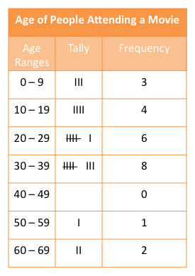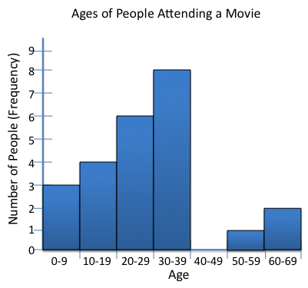

Frequency Table

Histogram

