Opposites Vocabulary
Vocabulary Word | Definition | Notes
Identity

Additive Identity

Opposite (English) |  | 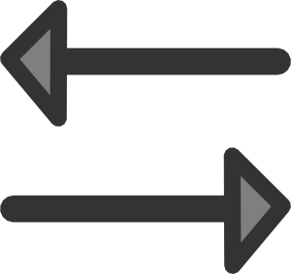
Opposite (Math)

Vocabulary Practice
What is the opposite?

1) 12 and ____
2) -3 and ____
3) ¾ and ____
4) 0 and ____
5) Bonus – What is the opposite of an opposite?
(For example -(-5)?)

