**Opposites Classwork**

1. Identify the additive opposite of the number, and then plot them both on a number line:

a) 9 and _____

b) -7.5 and _____

c) 4.25 and ____

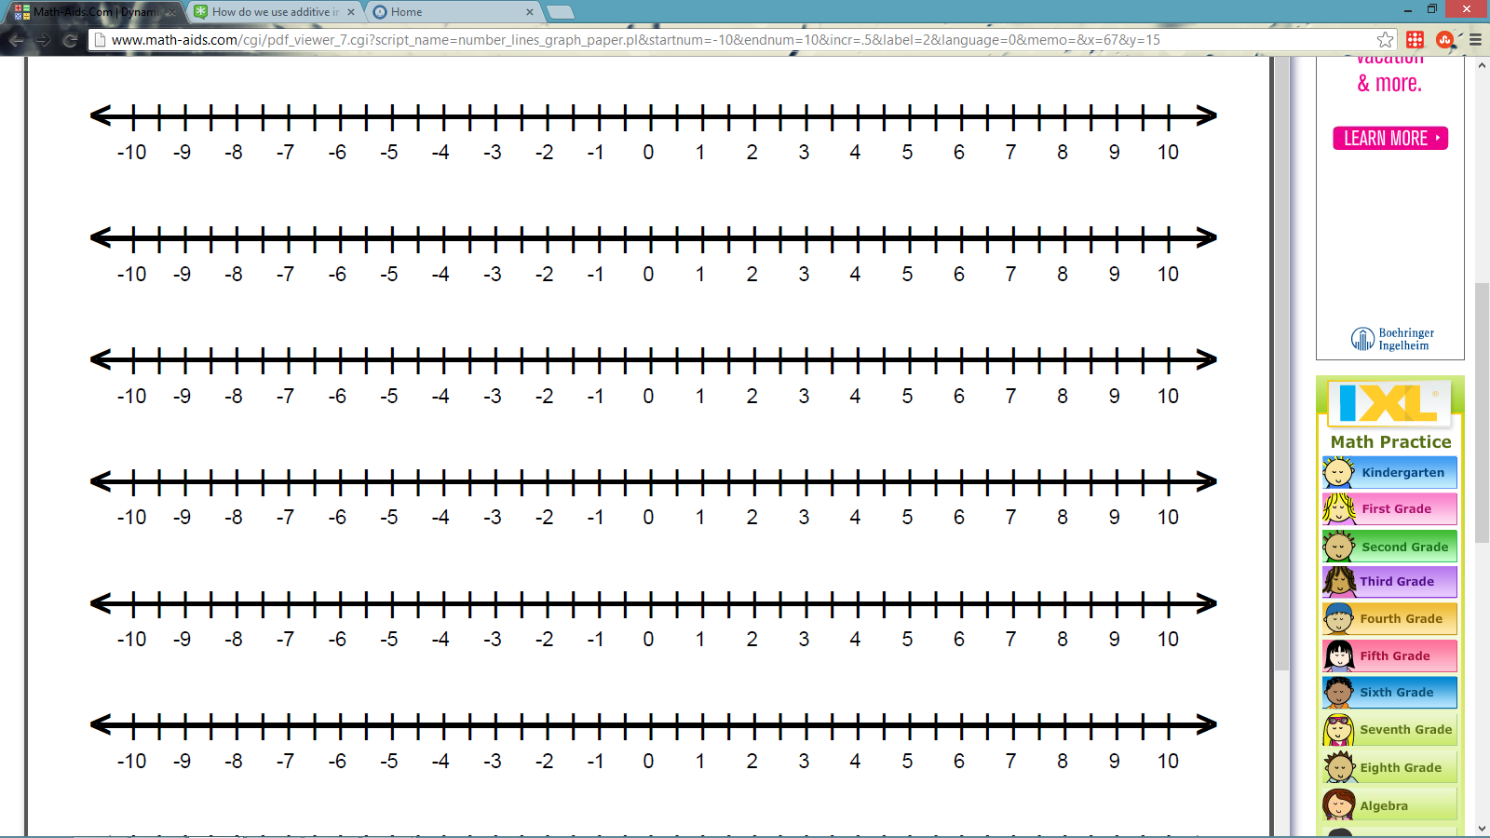





2. Evaluate the following:

a) 8 + (-8) = b) 14.6 + 0 =

c) -4 + 4 = d) - (-13) =

e) 9.6 + (-9.6) = f) 0 + (-3.2) =

g) -17 ½ + 0 = h) – (-3 ¼ ) =

3. Use the Number line and reflections to find the additive inverse.

a) What letter represents the opposite of a?_________________________________

b) What letter represents the opposite of b?_________________________________

c) What letter represents the opposite of c?_________________________________

d) What letter represents the opposite of –y?________________________________

(Careful! –y is not shown on the number line.)

e) What letter represents the opposite of z?__________________________________



y

x

w

z

b

a

c

d

0